**Environmental Variable Downscaling Technique**

**ArcGIS Model**

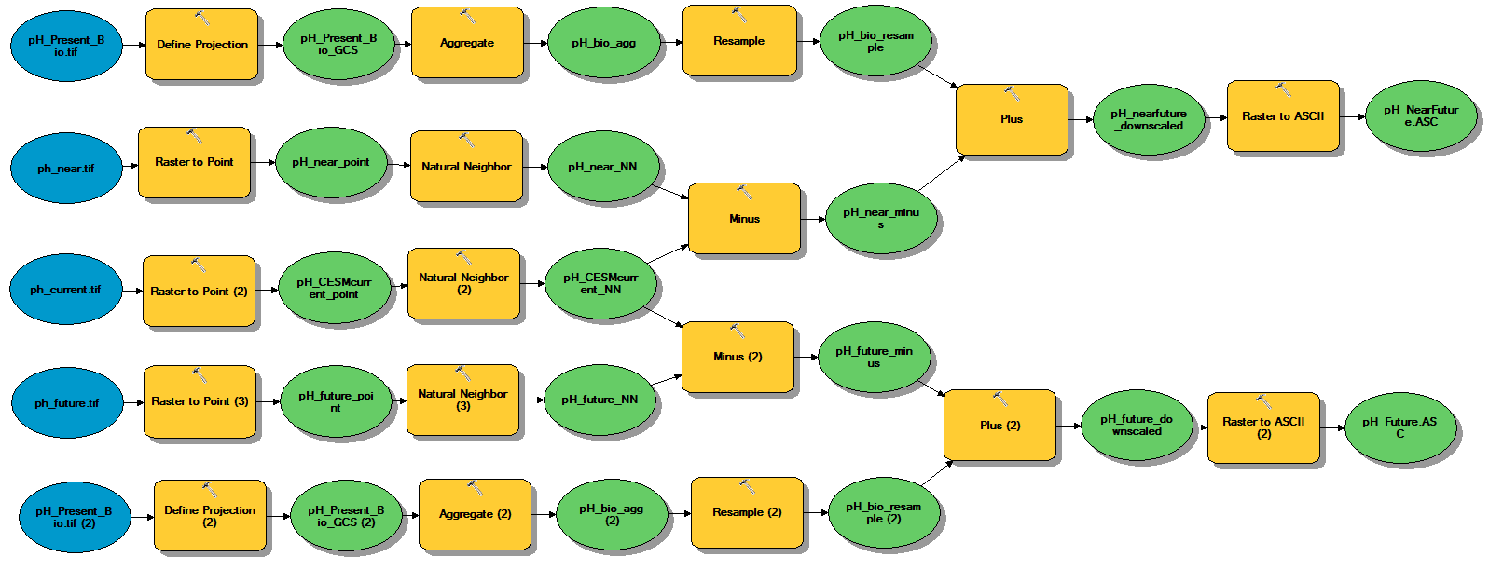

1. Import and define to GCS_WGS_1984:
   1. Bio-Oracle present day observed environmental variable (resolution = 0.083x0.083)
   2. CESM present day environmental variable (resolution = 1x1)
   3. CESM near-future environmental variable (resolution = 1x1)
   4. CESM future environmental variable (resolution = 1x1)
2. Convert **CESM** **present day, near-future, and future variables** to point data using “Raster to Point” function
3. Interpolate **CESM** **present day, near-future, and future** point datato fill in coastal values to cell size of 0.083 using “Natural Neighbor” function

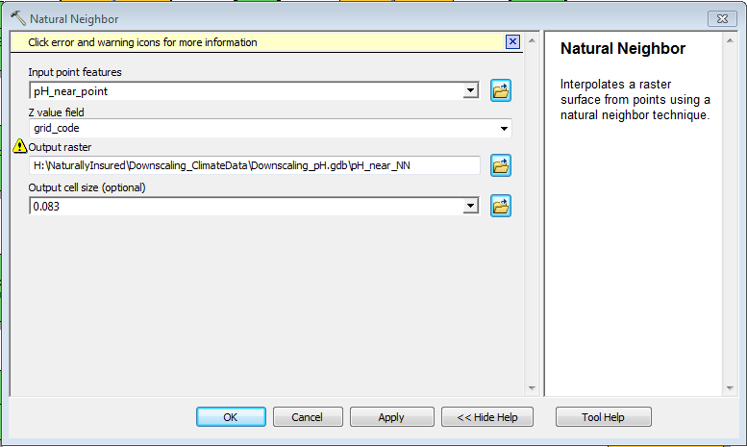

1. Find the difference between **CESM near-future & present day variables** using “Minus” function

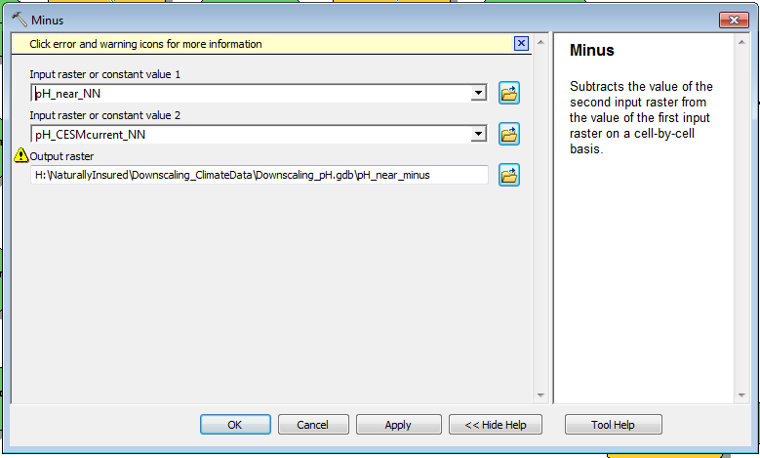

1. Aggregate **Bio-Oracle present day variable** by mean to a cell factor of 12 using “Aggregate” function

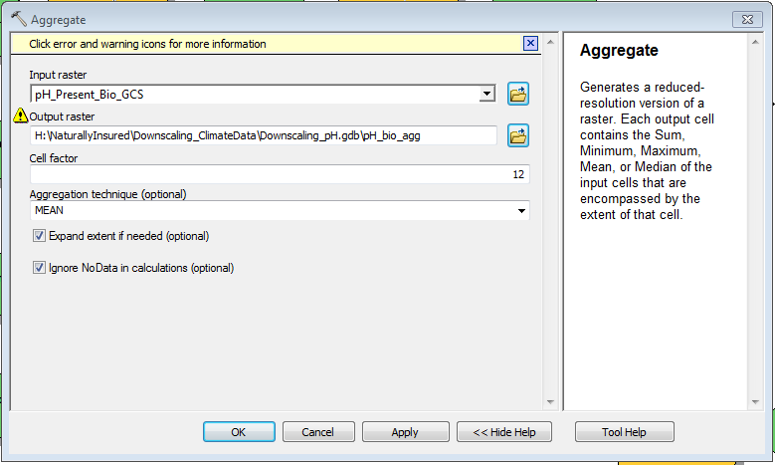

1. Resample **Bio-Oracle present day variable** using Bilinear technique to 0.083 x 0.083 cell size using “Resample” function

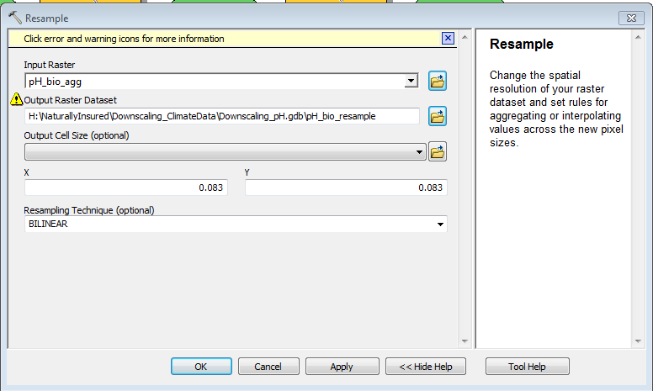

1. Add the difference between CESM near-future & present day to resampled Bio-Oracle present day variable using “Plus” function

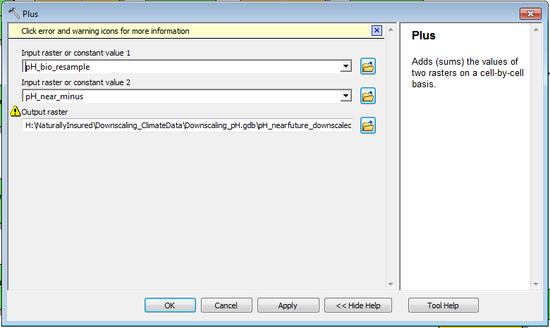

1. Repeat steps 4–7 for **future & present day conditions**
2. Clip raster to “Americas.shp” using Image Analysis window
   1. Highlight raster
   2. Click “add function” > right-click “Identity Function” > hover over “Insert Function” > click “Clip Function”
   3. Export clipped raster as a layer

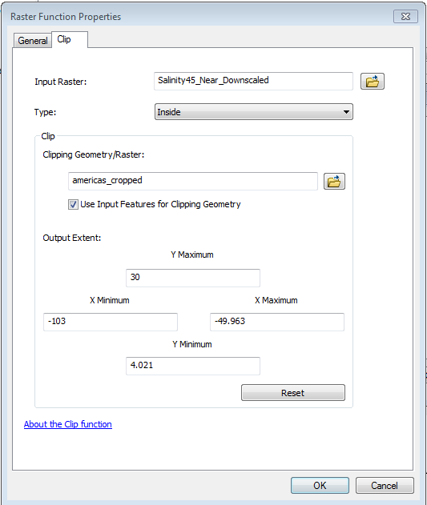

1. Convert to ASCII for Maxent using “Raster to ASCII” function & export ascii files